Prepositional Predicate

✅ What Is a Prepositional Predicate?
# Source: AI Source: Provided by: [Data Path: Persons Table -> ID Column: 1, Name_En Column: Motasem Essam] -> From: [ChatGPT] on [8/4/2025]
A Prepositional Predicate is a predicate that includes a main verb followed by a prepositional phrase that is essential to completing the meaning of the verb.
This often happens with prepositional verbs — verbs that require a specific preposition to convey their full meaning.

🔸 Key Features:
# Source: AI Source: Provided by: [Data Path: Persons Table -> ID Column: 1, Name_En Column: Motasem Essam] -> From: [ChatGPT] on [8/4/2025]
- Contains a verb + preposition combination.
- The prepositional phrase is not optional — it’s required to complete or clarify the predicate.
- Common in phrasal or prepositional verbs like: look at, rely on, deal with, believe in, listen to, talk about.

🔸 Examples of Prepositional Predicates:
# Source: AI Source: Provided by: [Data Path: Persons Table -> ID Column: 1, Name_En Column: Motasem Essam] -> From: [ChatGPT] on [8/4/2025]
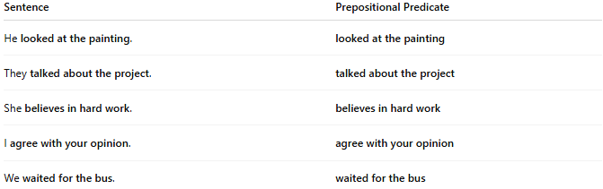
Sentence | Prepositional Predicate
He looked at the painting. | looked at the painting
They talked about the project. | talked about the project
She believes in hard work. | believes in hard work
I agree with your opinion. | agree with your opinion
We waited for the bus. | waited for the bus

🔸 Important Notes:
# Source: AI Source: Provided by: [Data Path: Persons Table -> ID Column: 1, Name_En Column: Motasem Essam] -> From: [ChatGPT] on [8/4/2025]
- Not all predicates containing a preposition are prepositional predicates.
- A true prepositional predicate depends on a verb that naturally combines with a preposition to form a complete idea.

🔸 Compare With Regular Verbal Predicate:
# Source: AI Source: Provided by: [Data Path: Persons Table -> ID Column: 1, Name_En Column: Motasem Essam] -> From: [ChatGPT] on [8/4/2025]
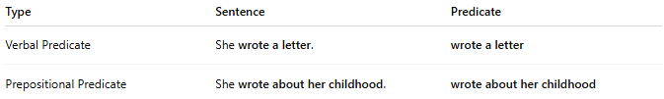
Type | Sentence | Predicate
Verbal Predicate | She wrote a letter. | wrote a letter
Prepositional Predicate | She wrote about her childhood. | wrote about her childhood

